**HTML <td> Tag**

Last Updated : 27 Aug, 2024

The **<td> tag** is used to define a standard cell in an HTML table. The ‘[rowspan](https://www.geeksforgeeks.org/html-td-rowspan-attribute/)‘ and ‘[colspan](https://www.geeksforgeeks.org/html-colspan-attribute/)‘ in the <td> tag tell how many rows or columns a cell covers, while e ‘id’ and ‘class’ help uniquely identify and style the cell using CSS, and ‘style’ determines its visual appearance.

**Syntax:**

<td>........</td>

**Types of cells:**

| **Cells** | **Description** |
| --- | --- |
| [**Header cells**](https://www.geeksforgeeks.org/html-td-headers-attribute/) | It contains header information(tags used for this is <th>). The text in **<th>** elements is bold and centered for heading by default. |
| **Standard cells** | It contains data(tags used for this is <td>). The text in **<td>** elements are regular and left-aligned for data by default. |

**Attributes Values :**

| **Attributes Values** | **Description** |
| --- | --- |
| [**rowspan**](https://www.geeksforgeeks.org/html-rowspan-attribute/) | It specifies the number of rows covered by the cell. |
| [**colspan**](https://www.geeksforgeeks.org/html-colspan-attribute/) | It determines the number of columns covered by the cell. |
| [**id**](https://www.geeksforgeeks.org/html-id-attributes/) | It identifies the data cell uniquely in the table. |
| [**class**](https://www.geeksforgeeks.org/html-class-attribute/) | It specifies the CSS class to style the cell. |
| [**style**](https://www.geeksforgeeks.org/html-style-tag/) | It gives the visual appearance of the cell through CSS properties. |

**There are many attributes supported by HTML4.1 but removed from HTML5 are listed below:**

| **Removed from HTML 5** | **Description** |
| --- | --- |
| [**abbr**](https://www.geeksforgeeks.org/html-abbr-tag/) | This attribute is used as an abbreviated version of the text content in a header cell. |
| [**align**](https://www.geeksforgeeks.org/html-td-align-attribute/) | It sets the alignment the text content within the table. |
| [**axis**](https://www.geeksforgeeks.org/html-td-axis-attribute/) | It categorizes header cells in the table. |
| [**bg color**](https://www.geeksforgeeks.org/html-td-bgcolor-attribute/) | It sets the background color of a header cell. |
| [**char**](https://www.geeksforgeeks.org/html-td-char-attribute/) | Aligns the content in a header cell to a character. |
| [**charoff**](https://www.geeksforgeeks.org/html-td-charoff-attribute/) | It is used to sets the number of characters that will be aligned from the character specified by the char attribute. The value of these attributes are in numeric form. |
| [**colspan**](https://www.geeksforgeeks.org/html-tdcolspan-attribute/) | Number of columns a header cell should span. |
| [**headers**](https://www.geeksforgeeks.org/html-td-headers-attribute/) | Specifies multiple header cells a cell is related to. |
| [**height**](https://www.geeksforgeeks.org/html-td-height-attribute/) | It sets the height of a header cell in the table. |
| [**nowrap**](https://www.geeksforgeeks.org/html-td-nowrap-attribute/) | It specifies that the content inside a header cell should not wrap. |
| [**scope**](https://www.geeksforgeeks.org/html-td-scope-attribute/) | It is used to specify the score of header content. |
| **sorted** | It is used to sort the direction of a column. |
| [**valign**](https://www.geeksforgeeks.org/html-td-valign-attribute/) | It is used to set the vertical alignment of text content. |
| [**width**](https://www.geeksforgeeks.org/html-td-width-attribute/) | It is used to set the width of a header cell. |

**Example 1:**This example showcases the use of the <td> tag within a table structure, emphasizing a simple representation of user data in a visually stylized manner using CSS for border and text color styling.



1

<!DOCTYPE html>

2

<html>

3

​

4

<head>

5

<title>td tag</title>

6

<style>

7

body {

8

text-align: center;

9

}

10

​

11

h1 {

12

color: green;

13

}

14

​

15

th {

16

color: blue;

17

}

18

​

19

table,

20

tbody,

21

td {

22

border: 1px solid black;

23

border-collapse: collapse;

24

}

25

</style>

26

</head>

27

​

28

<body>

29

<center>

30

<h1>GeeksforGeeks</h1>

31

<h2>td Tag</h2>

32

<table>

33

<thead>

34

<tr>

35

<th>Name</th>

36

<th>User Id</th>

37

</tr>

38

</thead>

39

<tbody>

40

<tr>

41

<td>Shashank</td>

42

<td>@shashankla</td>

43

</tr>

44

<tr>

45

<td>GeeksforGeeks</td>

46

<td>@geeks</td>

47

</tr>

48

</tbody>

49

</table>

50

</center>

51

</body>

52

​

53

</html>

**Output:**

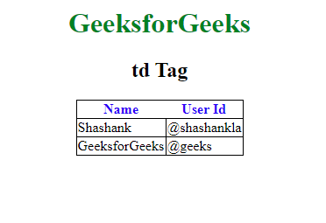

**Example 2 :**In this example, we will change background color and set the height of table cell.



1

<!DOCTYPE html>

2

<html>

3

​

4

<head>

5

<title>td tag</title>

6

</head>

7

​

8

<body>

9

<center>

10

<table border="1">

11

<tr>

12

<td style="background-color: lightblue; height: 40p">

13

Cell 1

14

</td>

15

<td>Cell 2</td>

16

</tr>

17

</table>

18

​

19

</center>

20

</body>

21

​

22

</html>

**Output:**

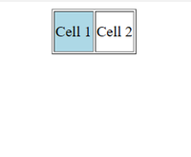

*Output*

**Example 3:**In this example, we will change width of a table cell and vertical align content inside <td>.



1

<!DOCTYPE html>

2

<html>

3

​

4

<head>

5

<title>td tag</title>

6

</head>

7

​

8

<body>

9

<center>

10

<table border="1" style="width:100%;

11

border: 1px solid black;

12

border-collapse: collapse;">

13

<tr>

14

<th style="width:50%">

15

Category

16

</th>

17

<th style="width:30%">

18

Amount

19

</th>

20

<th style="width:20%">

21

Percentage

22

</th>

23

</tr>

24

<tr>

25

<td style="vertical-align:bottom; height:100px;">

26

Groceries

27

</td>

28

<td style="vertical-align:bottom">

29

Rs250

30

</td>

31

<td style="vertical-align:bottom">

32

Rs50

33

</td>

34

</tr>

35

<tr>

36

<td style="vertical-align:bottom;">

37

Salary

38

</td>

39

<td style="vertical-align:bottom">

40

Rs200

41

</td>

42

<td style="vertical-align:bottom">

43

40

44

</td>

45

</tr>

46

</table>

47

</center>

48

</body>

49

​

50

</html>

**Output:**

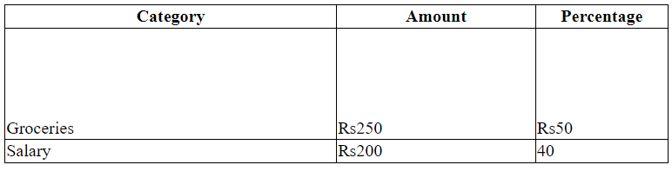

**Supported Browsers**

* [Google Chrome](https://www.geeksforgeeks.org/google-chrome-browser/)
* [Edge](https://www.geeksforgeeks.org/microsoft-edge-browser/)
* [Firefox](https://www.geeksforgeeks.org/mozilla-firefox-browser/)
* [Opera](https://www.geeksforgeeks.org/opera-browser/)
* [Safari](https://www.geeksforgeeks.org/apple-safari-browser/)

**HTML <td> Tag – FAQs**

**What is the difference between the <td> and <th> tags?**

*The <td> tag is used for regular table data cells, while the <th> tag is used for table header cells, which are typically styled as bold and centered by default.*

**Can the <td> tag span multiple columns or rows?**

*Yes, the <td> tag can span multiple columns using the colspan attribute and multiple rows using the rowspan attribute:*

*<td colspan="2">Spans two columns</td>  
<td rowspan="3">Spans three rows</td>*

**What is the default behavior of the <td> tag?**

*By default, <td> elements are displayed as block cells with left-aligned content. They automatically adjust their width based on the content and other cells in the same row.*

**How does the colspan and rowspan attributes affect table layout?**

*The colspan attribute allows a <td> cell to extend across multiple columns, while rowspan allows it to extend across multiple rows. This can significantly change the table layout by merging cells.*

**What happens if**